

Properties and Structures of Materials

(Bonding)

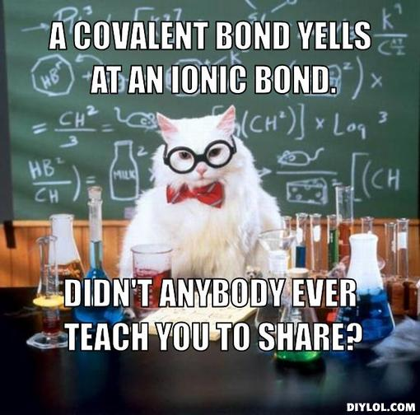

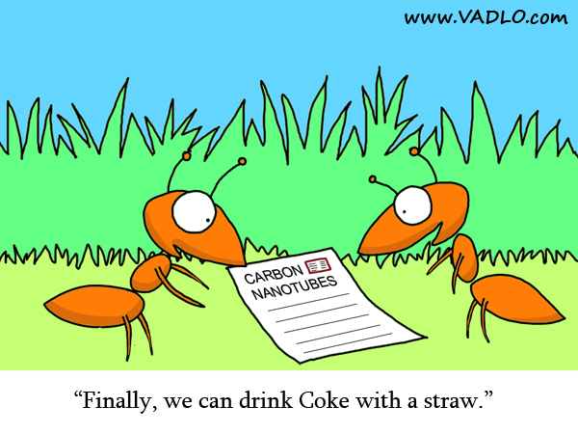

(NA 2014)

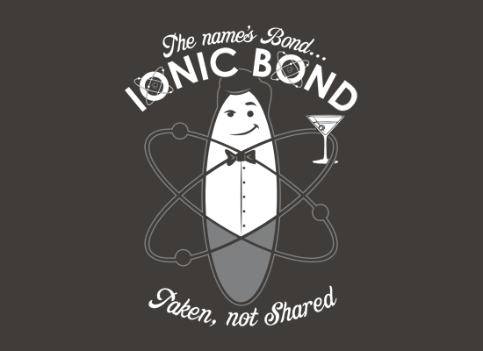 (Life in Research 2008)

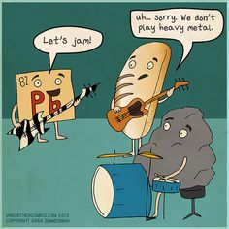

(Snorgtees nd)

(Brown nd)

|  |  |  |  |
| --- | --- | --- | --- |
| **Week** | **Outcomes** | **References** | **Tasks** |
| **6-7** | * materials are pure substances with distinct measurable properties, including melting and boiling points, reactivity, hardness and density; or mixtures with properties dependent on the identity and relative amounts of the substances that make up the mixture * pure substances may be elements or compounds which consist of atoms of two or more elements chemically combined; the formulae of compounds indicate the relative numbers of atoms of each element in the compound * differences in the physical properties of substances in a mixture, including particle size, solubility, density, and boiling point, can be used to separate them * nanomaterials are substances that contain particles in the size range 1–100 nm and have specific properties relating to the size of these particles which may differ from those of the bulk material * the type of bonding within ionic, metallic and covalent substances explains their physical properties, including melting and boiling points, conductivity of both electricity and heat and hardness * chemical bonds are caused by electrostatic attractions that arise because of the sharing or transfer of electrons between participating atoms; the valency is a measure of the bonding capacity of an atom * ions are atoms or groups of atoms that are electrically charged due to a loss or gain of electrons; ions are represented by formulae which include the number of constituent atoms and the charge of the ion  (for example, O2–, SO42–) * ionic bonding can be modelled as a regular arrangement of positively and negatively charged ions in a crystalline lattice with electrostatic forces of attraction between oppositely charged ions * the ionic bonding model can be used to explain the properties of ionic compounds, including high melting point, brittleness and non-conductivity in the solid state; the ability of ionic compounds to conduct electricity when molten or in aqueous solution can be explained by the breaking of the bonds in the lattice to give mobile ions * the formulae of ionic compounds can be determined from the charges on the relevant ions (refer to Appendix 2) * metallic bonding can be modelled as a regular arrangement of atoms with electrostatic forces of attraction between the nuclei of these atoms and their delocalised electrons that are able to move within the three dimensional lattice * the metallic bonding model can be used to explain the properties of metals, including malleability, thermal conductivity, generally high melting point and electrical conductivity; covalent bonding can be modelled as the sharing of pairs of electrons resulting in electrostatic forces of attraction between the shared electrons and the nuclei of adjacent atoms * the properties of covalent network substances, including high melting point, hardness and electrical conductivity, are explained by modelling covalent networks as three-dimensional structures that comprise covalently bonded atoms * elemental carbon exists as a range of allotropes, including graphite, diamond and fullerenes, with significantly different structures and physical properties * the properties of covalent molecular substances, including low melting point, can be explained by their structure and the weak intermolecular forces between molecules; their non-conductivity in the solid and liquid/molten states can be explained by the absence of mobile charged particles in their molecular structure | Lucarelli p23-25 Set 4(p25) q1-8  Lucarelli p54 Set 10(p54) q1-5  Lucarelli p55 Set 11(p56) q1-6  Lucarelli p57 Set 12(p59) q1-4  Lucarelli p60 Set 13(p62) q1-6  Lucarelli p63-66 Set 14(p67) q8,11-14  STAWA Experiment 2 p13  STAWA Experiment 3 p15  STAWA Experiment 13 p36 | **Task 4: Test- Properties and structure of materials: bonding** |

**Ionic compounds**

Remember, ionic compounds are formed between a metal and a non-metal and also include ammonium compounds.

* Use the ions table
* Do **not** use mono, di, tri tetra etc

|  |  |
| --- | --- |
| **Name** | **Formula** |
| Potassium permanganate |  |
| Magnesium chloride |  |
| Aluminium chloride |  |
| Sodium nitrate |  |
| Sodium dichromate |  |
| Sodium phosphate |  |
| Calcium nitrite |  |
| Calcium nitrate |  |
| Calcium nitride |  |
| Zinc sulphite |  |
| Zinc sulphate |  |
| Zinc sulphide |  |
| Iron (II) oxide |  |
| Iron (III) oxide |  |
| Copper (I) hydroxide |  |
| Copper (II) hydroxide |  |
| Ammonium nitrate |  |
| Ammonium iodide |  |
| Ammonium sulphate |  |
|  | AgCl |
|  | AgCH3COO |
|  | Ag2O |
|  | MgO |
|  | Mg3(PO4)2 |
|  | SnCO3 |
|  | SnCl4 |
|  | NaHCO3 |
|  | Ba(CH3COO)2 |
|  | Cr2S3 |

**Covalent compounds**

Remember covalent compounds are formed between non-metals.

* Do not use ions table
* Use mono, di, tri, tetra, penta, hexa, hepta, octa, nona, deca

|  |  |
| --- | --- |
| **Name** | **Formula** |
|  | SO2 |
|  | SO3 |
| Carbon monoxide |  |
| Carbon dioxide |  |
| Trisulfur octaoxide |  |
|  | P2F6 |
|  | N2O5 |
|  | N2O3 |

**Covalent compounds known by their common name are:**

**Water H2O**

**Ammonia NH3**

**Organic compounds like methane CH4  are named by a system you will learn in Upper school.**

**Acids that you are expected to learn are:**

**Hydrochloric acid HCl**

**Ethanoic (acetic) acid CH3COOH**

**Nitric acid HNO3**

**Sulfurous acid H2SO3**

**Sulfuric acid H2SO4**

**Carbonic acid H2CO3**

**Phosphoric acid H3PO4**

**Nanotechnology**

* What are nanoparticles?
* What is nanotechnology?
* Outline an example of a nanotechnology and its application.
* List some of the instruments used to image and manipulate nanoparticles.

**Allotropes**

* Define an allotrope.

______________________________________________________________________________________________________________________________________________________

Briefly discuss the following allotropes with reference to their structure and use. Include a diagram in your discussion.

Diamond

Graphite

Carbon nanotubes

**Lewis diagrams**

Valence electrons in an atom, molecule or ion are shown as a dot or cross (a line can be used to represent a pair of electrons but this is usually reserved for molecules or polyatomic ions).

Examples:

**Atoms**  hydrogen atom aluminium atom bromine atom

H Al Br

**Monatomic Ions** sodium ion strontium ion phosphide ion iodide ion

[Na]+ [Sr]2+ [ P ]3- [ I ]‒

**Covalent molecules** - atoms within a covalent molecule share electrons to achieve a noble gas configuration (in general this is eight electrons in the valence shell and so is called the octet rule). In sharing these electrons, the bonds formed can be single bonds (sharing two electrons), double bonds (sharing four electrons) or triple bonds (sharing six electrons).

chlorine carbon dioxide

C*l* C*l* O C O

**Formation of ionic compound-** Magnesium has two valence electrons and oxygen has six valence electrons. Oxygen gains magnesium’s two valence electrons. This produces Mg2+ ions and O2- ions. The ions now have eight electrons in their valence shells.

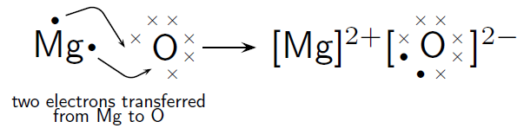

**1. Metallic bonding**:

The bonding between atoms within a single metal.

**Definition**:

Metallic bonding is the strong electrostatic attraction force between the metal cations/nuclei and the delocalized (ie mobile) valence electrons.

**Diagram**

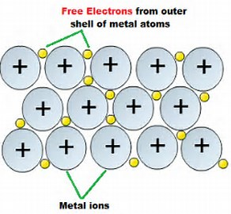 (ClipartXtras, 2017)

***Examples***

Iron, Aluminium, Brass

**Properties**

1. Good conductors of electricity

Metallic substances contain delocalized valence electrons which are free to move and conduct a current.

1. Relatively high melting and boiling points

The electrostatic attraction between the positive metallic ions and delocalized valence electrons in the metal is strong and it requires a lot of energy to break these bonds.

1. Hardness

Strong electrostatic attraction forces between the positive metallic ions and delocalized valence electrons which requires a big force to break these bonds.

1. Malleability/Ductility

Hammered into sheets or drawn out into wires. This is because as a force is applied to the metal and the positive metal nuclei are pushed closer together, the mobile valence electrons can move in between the nuclei to minimise repulsion.

1. Lustre

The interaction between the incoming light and the delocalized valence electrons causes the metal to shine.

**2. I*onic bonding***

Between metals and non-metals (also ammonium compounds are ionic)

**Definition:**

Ionic bonding is the strong electrostatic attraction force between the positive cations and negative anions in an ordered, three- dimensional lattice.

The metal atom transfers electrons to the non-metal atom.(Metals lose electrons to gain a full valence shell and non-metals gain electrons to obtain a full shell). By doing so, the metal atom changes into a positive ion and the non-metal atom changes into a negative ion. This two oppositely charged ions attract each other with strong electrostatic forces to form a crystal lattice.

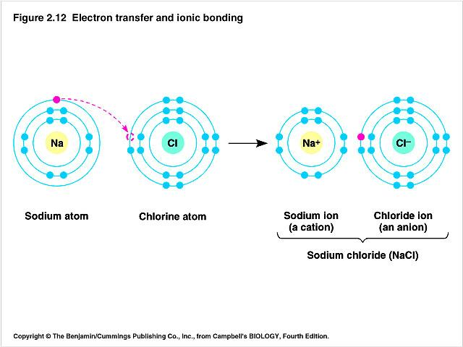

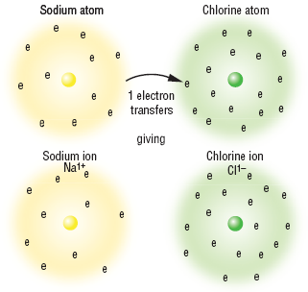

***Examples*** NaCl, Mg(NO3)2

**Properties**

1. Conductivity

Do not conduct in the solid state because the ions are held in fixed positions in the lattice and are therefore not able to move in order to conduct a current.

In the molten state or in solution the ions separate from the lattice and become free to move and so can conduct a current.

1. Melting point and boiling points

High because of the strong electrostatic attraction force between the oppositely charged ions in the lattice which requires a lot of energy to break these bonds in order to separate the ions.

1. Brittle

In the lattice the particles are packed in fixed positions. Applying a force will force same charged particles together and they will repel each other. These forces of repulsion will shatter the structure.

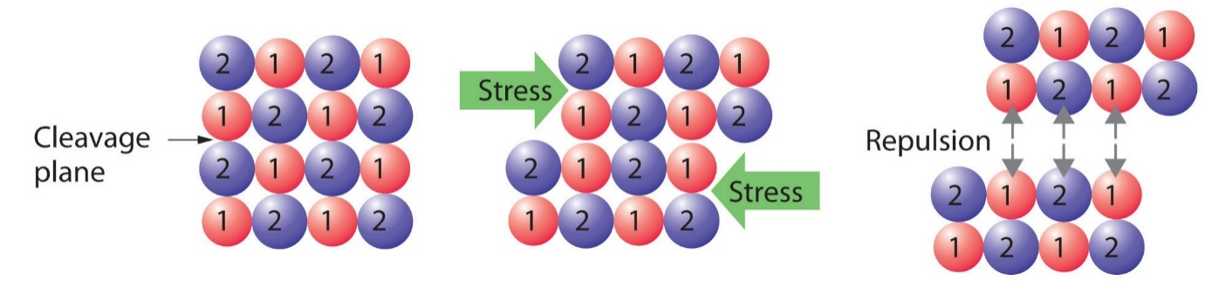

**3. Covalent bonding**

Between non-metals

**Definition:**

Covalent bonding is due to the strong electrostatic attraction between the shared valence electrons and the positive nuclei of the atoms involved in the bond. This can occur to form **molecules** or **networks.**

Both non-metals want to gain electrons to fill their outer shell. Electron sharing takes place between the two atoms to fill both their outer shells with 8 electrons.

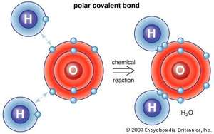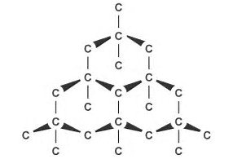

**Covalent bonds between hydrogen and oxygen in water molecule Covalent bonds between carbon atoms in diamond network**

***Examples***

Covalent molecular: CO2, H2O, NH3, C8H18

Covalent network: SiC, diamond, SiO2

**Properties of covalent molecular substances**

1.Conductivity

Do not conduct in any state. All electrons are held tightly in bonds and so there are no free moving electrons to conduct a current.

2. Melting pointing and boiling points

Low (usually gases and some liquids at room temperature) because there are weak intermolecular forces between the molecules which doesn’t require a lot of energy to overcome in order to separate the molecules.

3.Hardness

Soft because the weak intermolecular forces between the molecules doesn’t require a big force to overcome in order to separate the molecules.

**Properties of covalent network substances**

1. Conductivity

Do not conduct in any state. All electrons are held tightly in bonds and so there are no free moving electrons to conduct a current.

2. Melting and boiling points

Very high because multiple strong covalent bonds between atoms in the network have to be broken which requires a lot of energy.

3. Hardness

Very hard because multiple strong covalent bonds between atoms in the network have to be broken which requires a large force.

4. Brittle

A force can disrupt the lattice

1. **Melting and Boiling Points**

a) Why do metallic compounds have high melting and boiling points?

The electrostatic attraction between the positive metallic ions and delocalized valence electrons in the metal is strong and it requires a lot of energy to break these bonds.

b) Why do ionic compounds have high melting points?

The electrostatic attraction between the oppositely charged ions in the lattice is strong and it requires a lot of energy to separate the ions.

c) Why do covalent molecular substances have low melting and boiling points?

The attraction between the molecules is weak (the intermolecular force is weak) and it does not require a lot of energy to separate the molecules.

d) Why do covalent network substances have high melting and boiling points?

The atoms in a covalent network substance are strongly covalently bonded in a giant network so multiple strong covalent bonds need to be broken in order for the substance to melt or boil and this will therefore require a lot of energy.

1. **Electrical conductivity**

a) Why are metallic substances good conductors of electricity?

**Metallic substances contain delocalized valence electrons which are free to move and conduct a current.**

b) Why can ionic substances conduct electricity when they are molten (melted) or dissolved in water (in solution) but not when they are solid?

**In the solid form the ions in the ionic compound are held in fixed positions in the lattice and are therefore not able to move in order to conduct a current. When the ionic compound is melted or dissolved, however, the ions separate from the lattice and become free to move and so can conduct a current.**

c) Why do covalent molecular substances not conduct electricity in any form?

**All electrons in covalent molecular substances are held tightly in bonds and there are therefore no electrons that are free to move and conduct a current. The molecules are also not charged species so they cannot carry charge and conduct a current.**

d) Why do covalent network substances not conduct electricity in any form?

**All electrons in covalent network substances are held tightly in bonds and there are therefore no electrons that are free to move and conduct a current.**

1. **Explain why metals can be beaten into shape but ionic compounds are crystalline and shatter into pieces when beaten.**

* When metals are beaten, the delocalized valence electrons are able to move in between the positive metallic nuclei and minimise repulsion.
* When ionic compounds are beaten the ions of the same charge will be forced together and they will repel each other. This will cause the crystal to break/ shatter.

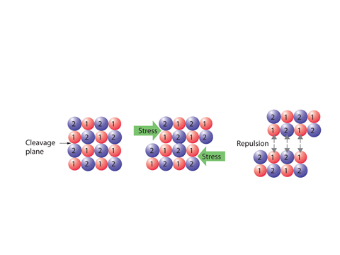

# Bibliography

Brown, J. "Science." *Pintrest.* nd. https://www.pinterest.com/julsb98/science/ (accessed February 26, 2015).

Life in Research. "Life in Research Cartoon #21." *Vadlo Life Sciences Search Engine.* 2008. http://vadlo.com/cartoons.php?id=21 (accessed February 26, 2015).

NA. "Chemsirty Cat Meme Generator." *Pics & photos.* 2014. http://funny-pictures.picphotos.net/chemistry-cat-meme-generator-diy-lol510/assets.diylol.com*hfs*6f8*5a9*51e*resized*chemistry-cat-meme-generator-a-covalent-bond-yells-at-an-ionic-bond-didn-t-anybody-ever-teach-you-to-share-3ad3fd.jpg/ (accessed February 26, 2015).

Snorgtees. "The NAme's Bond, Ionic Bond." *Snorg Tees.* nd. http://www.snorgtees.com/the-name-s-bond-ionic-bond (accessed February 26, 2015).

Davis, A. *Nelson Chemistry Units 1 & 2.* South Melbourne: Cengage Learning Australia Pty Limited, 2014.

Lucarelli, N. *ESSENTIAL CHEMISTRY Australian Curriculum for WA ATAR Chemistry Units 1 + 2.* Willetton: Lucas Publications, 2014

Clark, J and Baddock, M *Exploring Chemistry Year 11 Experiments, Investigations and Problems* Osborne Park STAWA, 2014.

ClipartXtras. (2017). *28 Collections of Metallic Bonding Drawings*.

edspeaksny. (2012, May 28th). *Kids Speak: Chemistry Can be Cool.* Retrieved from Education Speaks: http://educationspeaks.org/2012/05/kids-speak-chemistry-can-be-cool/

NA. (2013). *Johnny Was A Chemist's Son.* Retrieved from Pickycovers: http://www.pickycovers.com/cover/742/johnny-was-a-chemists-son